Your Name here

[Draw your reader in with an engaging abstract. It is typically a short summary of the document. When you’re ready to add your content, just click here and start typing.]
[Document title]
Computer Science NEA

Contents
Developmental Testing 2
Testing 0

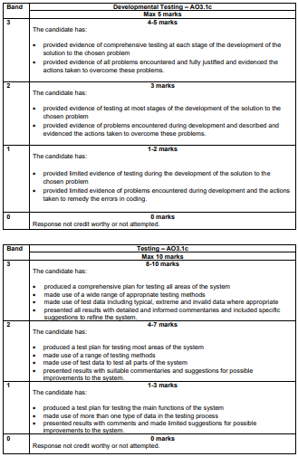

This is for your reference only and needs to be deleted when it is handed in as a final copy.

Please also delete any of my comments from the sections below, on final hand in

Developmental Testing
You need to demonstrate your problem solving, what errors have you encountered and how did you solve them. Each error should have a print screen of the problem and one of the solution with some commentary.

Testing
Use the testing table to fully test your system. You MUST include a wide range of tests, this includes valid, invalid, extreme and erroneous data. Every test that fails must have some commentary explaining how you will fix it.
You can evidence this through screen shots, shown below the table or video evidence. Whichever you decide the moderator must be able to find easily.
Test No | Test description | Test Type | Test Data | Expected Outcome | Actual Outcome | Commentary
 | Password entry | Valid | Password | Password will be accepted | Password was accepted
 |  | Invalid | password | Password will be rejected | Password was accepted | I have set the field to be not case sensitive I have updated this – see images below.

